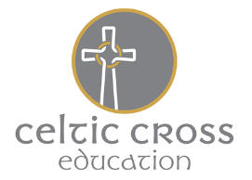
Celtic Cross Education Multi-Academy Trust of Schools
Ladock C of E School
Safeguarding Children
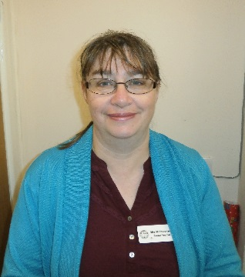
Our Designated Safeguarding Lead is
Mary Stevenson
Deputy – Julie Gilbert
mary.stevenson@celticcross.education (01726 882622)
julie.gilbert@celticcross.education (01726 882622)

Our designated Children in Care teacher is Mary Stevenson (mary.stevenson@celticcross.education 01726 882622)
Our SENCO is Rachel Moseley (Rachel.moseley@celticcross.education)

Child Protection Statement
Safeguarding Children in Ladock C of E School

Our school community has a duty to safeguard and promote the welfare of children who are our pupils. This means that we have a Child Protection Policy and procedures in place, which we refer to in our school prospectus. All staff, including our volunteers and supply staff must ensure that they are aware of these procedures. They are also all DBS checked. Parents and carers are welcome to read these upon request.
Sometimes, we may need to share information and work in partnership with other agencies when there are concerns about a child’s welfare. We will endeavour to ensure that our concerns about pupils are discussed with their parents/carers first, unless we have reason to believe that this is not in the child’s best interests.

