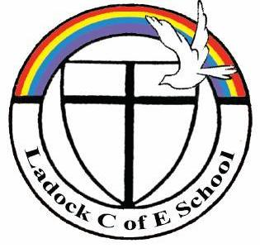

6th October 2017

Dear Parents,
It was lovely to see so many of you at the open afternoon on Tuesday. We hope you enjoyed the opportunity to visit your child’s classroom and take part in story time. We felt it was a great success and the children were certainly very keen to show you around, especially their new pirate ship!
We felt this was such a valuable experience for yourselves and the children that we would really like to offer this opportunity more regularly. Therefore, we will be holding an open afternoon in St Cuby Class once a month! The format will stay the same - you will be welcome to come into the classroom (via the outside door) at 2.45 to share your child’s learning and then enjoy story time with them at 3.00. This will also be a good chance for you to ask us any questions you might have about how they are getting on as the year progresses.
The proposed dates for the open afternoons are as follows…
28th November, 12th December, 30th January, 27th February, 27th March, 24th April, 22nd May, 26th June, 17th July
**Please note these days may be subject to change!**

Very best wishes,

Mrs Hayes and Mrs Rimmer

