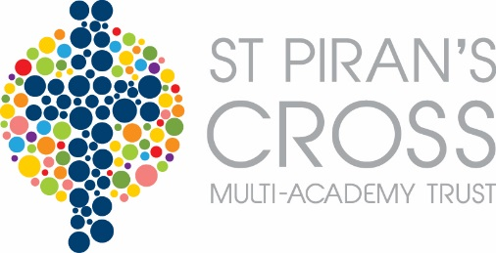

Health and Safety Policy
Contents
 | Page
MAT Statement of Safety Policy | 2
MAT Roles and Responsibilities | 3
MAT Arrangements for Health and Safety | 3
Local Roles and Responsibilities | Additional document
Local Arrangements for Health and Safety | Additional policy document

Statement of Health and Safety Policy

St Piran’s Cross Multi-Academy Trust :-
- Recognises its legal and moral responsibilities to persons who may be adversely affected by the Multi Academy Trust’s activities.
- Is committed to ensuring, by all reasonably practical means, the health, safety and welfare of its students, visitors, employees and contractors involved with its activities.
- Will seek to ensure that its legal duties and policy objectives are complied with at all times.
- Will ensure that all foreseeable risks associated with the Multi Academy Trust’s activities are identified and removed or controlled through a process of risk assessment and management.
- Will ensure that all employees are given such information, instruction and training as may be necessary to enable the safe performance of their duties.
- Will seek to inform students’ parents or guardian of any health, safety or welfare issues relevant to their child or children.
- Have detailed the arrangements for health safety and welfare in the Organisation and Arrangements associated with this policy statement.
- Will ensure, as far as is reasonably practical, that this policy statement and supporting documents are kept up-to-date. A formal review and re-adoption of this policy will be carried out by no later than November 2017.

Approved and adopted by:
Chair of the Board of Trustees |  | Principal

On: 9th December 2016

Multi Academy Trust Responsibilities
It is recognised that individuals and groups of individuals have responsibilities for health safety and welfare in the Multi Academy Trust (MAT). The individuals and groups identified below are expected to have read and understood the MAT’s policies and procedures for ensuring health safety and welfare and to conduct their duties in accordance with them.

The employer
The employer in this MAT is The Academy Trust. The employer has the ultimate responsibility and must ensure that there are arrangements in place for the health safety and welfare of students, staff, visitors and contractors.

Board of Trustees
The Trustees are responsible for ensuring that mechanisms and procedures are in place for health safety and welfare. The trustees will receive regular reports to enable them, in collaboration with the Governors and Head/Principal, to prioritise resources for health safety and welfare issues.
The Board of Trustees have appointed the Business Manager to oversee the management of health and safety across the MAT.

Principal
The Principal has responsibility for:-
- Day-to-day management of all health safety and welfare matters in the MAT in accordance with the Statement of Safety Policy;
- Ensuring that regular health safety and welfare inspections are carried out;
- Submitting regular health safety and welfare reports to the employer;
- Ensuring that action is taken on health safety and welfare issues;
- Passing on information received on health safety and welfare matters to appropriate people;
- Carrying out accident investigations;
- Chairing the MAT Health and Safety Committee;
- Identifying and facilitating employee training needs;
- Liaising with governors and the employer on policy issues and any problems in implementing the Safety Policy;
- Co-operating with and providing necessary facilities for trades union safety representatives;
- Providing necessary facilities for all employees to be consulted on health safety and welfare matters;
- Ensuring that any contractor appointed to deliver services or carry out work is competent to do so;
- Monitoring contractors to ensure that the Health and Safety Policy is complied with;
- Take action where any contractor is found to be working in a manner which is considered to be unsafe.
Whilst responsibility for the above cannot be delegated, the function of carrying out these tasks can be delegated to other members of staff. In this MAT the following functions have been delegated to:-
Function | Delegated to
Day to day health safety and welfare management | Heads
Regular inspections | Daily - Heads,  Weekly - Trust Site Supervisor  Termly - Business Manager
Accident Investigation | Heads
Chairing Health and Safety Committees | Rev David Michael
Employee training needs | Business Manager/HR Officer
Contractor management | Business Manager

Competent Health and Safety Advice
The MAT recognises that it must have access to competent health and safety advice. The MAT’s competent advisors are
The Health, Safety and Wellbeing Services Team, Cornwall Council

