Pupil premium strategy statement – Ladock Church of England School
At Ladock C of E Primary School all members of staff and governors accept responsibility for all pupils recognising that a number of pupils within the school population, some of whom are not eligible for pupil premium funding, may at any point during their school career require additional support and intervention. We are committed to meeting our pupils’ pastoral, social and academic needs in a nurturing environment. As with every child in our care, a child who is in receipt of the pupil premium is valued, respected and entitled to develop to their full potential. The ultimate objectives for our pupils who are in receipt of pupil premium are:
• To ensure the attendance of pupils in receipt of pupil premium is at least in line with those of peers in school. We know that children learn best when they attend school regularly. However, the attendance of the pupil premium group is lower than the attendance of those not in receipt of pupil premium. In our strategy, we focus on encouraging attendance through meeting the well-being needs of pupils and families, by providing exciting learning opportunities throughout the school and monitoring, intervening, and supporting families when attendance drops below their peers.
• To continue to ensure the outcomes for pupils in receipt of pupil premium are at least in line with those of peers in school across the curriculum. Almost 30% of our pupils in receipt of pupil premium have identified special educational needs. In all cases we strive to ensure all our pupils make excellent progress. We believe that all our pupils benefit from high quality teaching every day and we ensure our strategy provides for this with further additional intervention where required.

• Ensure the well-being needs of all pupils in receipt of pupil premium funding are met meaning they are not impeded by various school opportunities. Children in receipt of pupil premium are entitled to breakfast/afterschool club vouchers, fresh fruit, subsides for school trips, outing and camps

This statement details our school’s use of pupil premium funding to help improve the attainment of our disadvantaged pupils.
It outlines our pupil premium strategy, how we intend to spend the funding in this academic year and the outcomes for disadvantaged pupils last academic year.

School overview
Detail | Data
Number of pupils in school | 79
Proportion (%) of pupil premium eligible pupils | 19% (15)
Academic year/years that our current pupil premium strategy plan covers (3-year plans are recommended – you must still publish an updated statement each academic year) | 2025/26  2026/27  2027/28
Date this statement was published | 01/12/2025
Date on which it will be reviewed | 01/12/2026
Statement authorised by | T Hobbs
Pupil premium lead | T Hobbs
Governor / Trustee lead | A Nicholson

Funding overview
Detail | Amount
Pupil premium funding allocation this academic year | £16665
Pupil premium funding carried forward from previous years (enter £0 if not applicable) | £0
Total budget for this academic year  If your school is an academy in a trust that pools this funding, state the amount available to your school this academic year | £16665

Part A: Pupil premium strategy plan

Statement of intent

Challenges
This details the key challenges to achievement that we have identified among our disadvantaged pupils.
Challenge number | Detail of challenge
1 | Ensure the change in class structure meets the needs of the children in KS1
2 | Ensure that there is support for children in Ks2 that may require interventions
3 | Pupils' emotional well-being, social and behavioural needs affecting children being in a position to able to make progress and their readiness to learn
4 | Almost 30% of pupils who qualify for Pupil Premium funding have specific SEND needs and require specific intervention based on targets from professional reports.
5

Intended outcomes
This explains the outcomes we are aiming for by the end of our current strategy plan, and how we will measure whether they have been achieved.
Intended outcome | Success criteria
To ensure that the combined class of KS1 is meeting the needs of disadvantaged children and their progress is in line with their peers. | Increase the progress of a key group of children in receipt of pupil premium in reading, writing and maths in line with their identified baseline.
To ensure that children in receipt of pupil premium across ks2 access regularly and timely interventions as required. | Increase the progress of a key group of children in receipt of pupil premium in reading, writing and maths in line with their identified baseline.
To ensure that emotional support is available for children across the school to allow them to access the curriculum. | Trained adults across the school to support the emotional needs of children with regular TIS based interventions. Access to MHST for additional support.
To ensure all pupils in receipt of pupil premium, including those with SEND, make expected progress from their starting points | Children’s well-being needs are met and supported to ensure they are attending school more regularly and able to access high quality teaching and targeted interventions where needed to support them in making progress. Attendance target 97.5%

Activity in this academic year
This details how we intend to spend our pupil premium funding this academic year to address the challenges listed above.

Teaching (for example, CPD, recruitment and retention)
Budgeted cost: £ 10,500
Activity | Evidence that supports this approach | Challenge number(s) addressed
Teaching assistant interventions | EEF report evidences progress  Teaching Assistant Interventions | EEF | 1,2,4
Review current provision alongside the guidance: ‘Special Educational Needs in Mainstream,’ | See EEF research guidance report: Special Educational Needs in Mainstream School published in March 2020. Ensure all pupils have access to high quality teaching. Compliment high quality teaching with small group and one to one interventions. https://educationendowmentfoundation. org.uk/educationevidence/guidancereports/sen | 4
Metacognition and self regulation | EEF evidences support for all learners  Metacognition and self-regulation | EEF | 2,3

Targeted academic support (for example, tutoring, one-to-one support, structured interventions)
Budgeted cost: £ 4,500
Activity | Evidence that supports this approach | Challenge number(s) addressed
Establish small group intervention for disadvantaged pupils falling behind age-related expectations | EEF Toolkit guidance: https://educationendowmentfoundation.or g.uk/support-forschools/schoolimprovement-planning/2- targetedacademic-support  ‘Some pupils may require additional support alongside high-quality teaching in order to make good progress. The evidence indicates that small group and one to one interventions can be a powerful tool for supporting these pupils when they are used carefully.’ | 1,2,4
Effective deployment of staff, Teaching Assistant and HLTA to support key children and year groups. Teaching Assistant to deliver pastoral groups, positive play at playtimes, out-door learning, settling child into school in the morning. | ’ EEF research guidance: https://educationendowmentfoundation.or g.uk/educationevidence/guidancereports/teachingassitants ‘Research on TAs delivering targeted interventions in one-to-one or small group settings shows a consistent impact on attainment of approximately three to four additional months’ progress (effect size 0.2 – 0.3). Crucially, these positive effects are only observed when TAs work in structured settings with high quality support and training. When TAs are deployed in more informal, unsupported instructional roles, they can impact negatively on pupils’ learning outcomes | 1,2,3,4

Wider strategies (for example, related to attendance, behaviour, wellbeing)
Budgeted cost: £1,665
Activity | Evidence that supports this approach | Challenge number(s) addressed
To broaden disadvantaged pupil’s range of opportunities and access to all aspects of school life by subsidising the cost of school trips, workshops, camps and breakfast/after school club, including ensuring that they have the best possible access to immediate remote learning. | EEF Life skills and enrichment from the teaching and learning toolkit alongside the findings from recent EEF projects EEF Using digital technology to improve learning | 3,4

Total budgeted cost: £16665

Part B: Review of the previous academic year

Outcomes for disadvantaged pupils
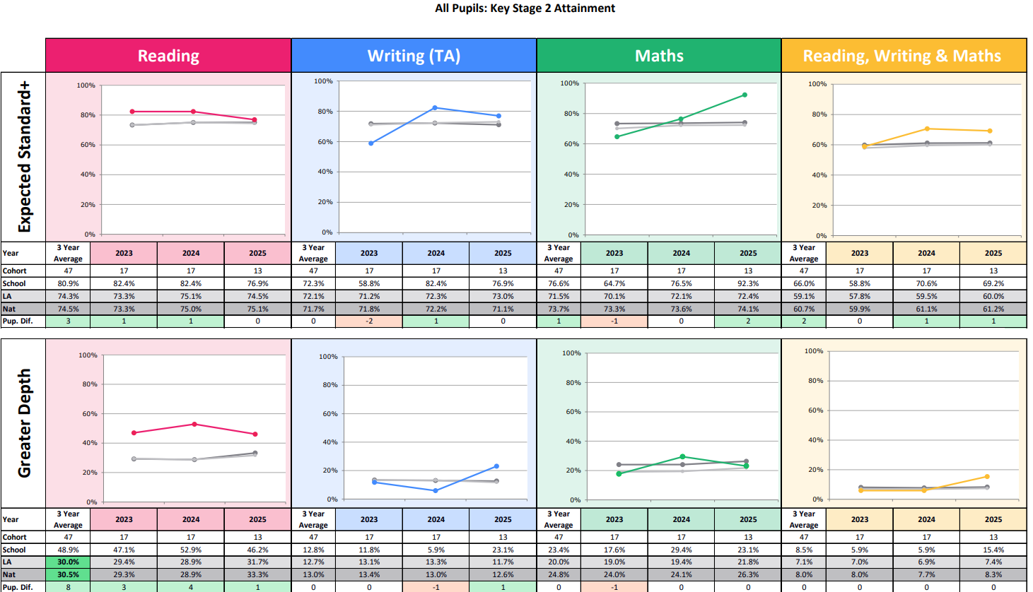
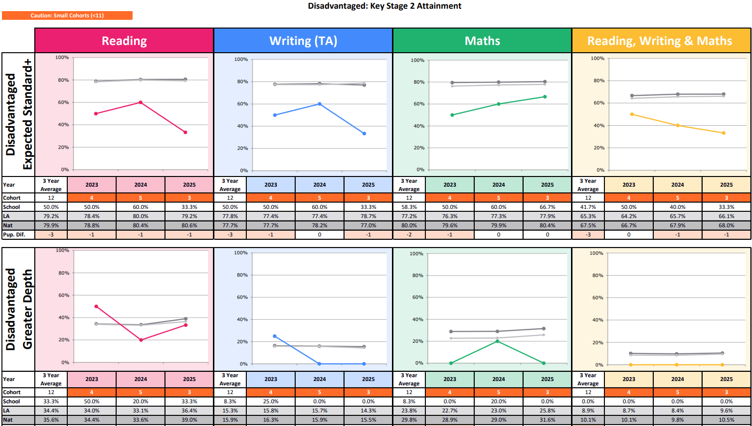
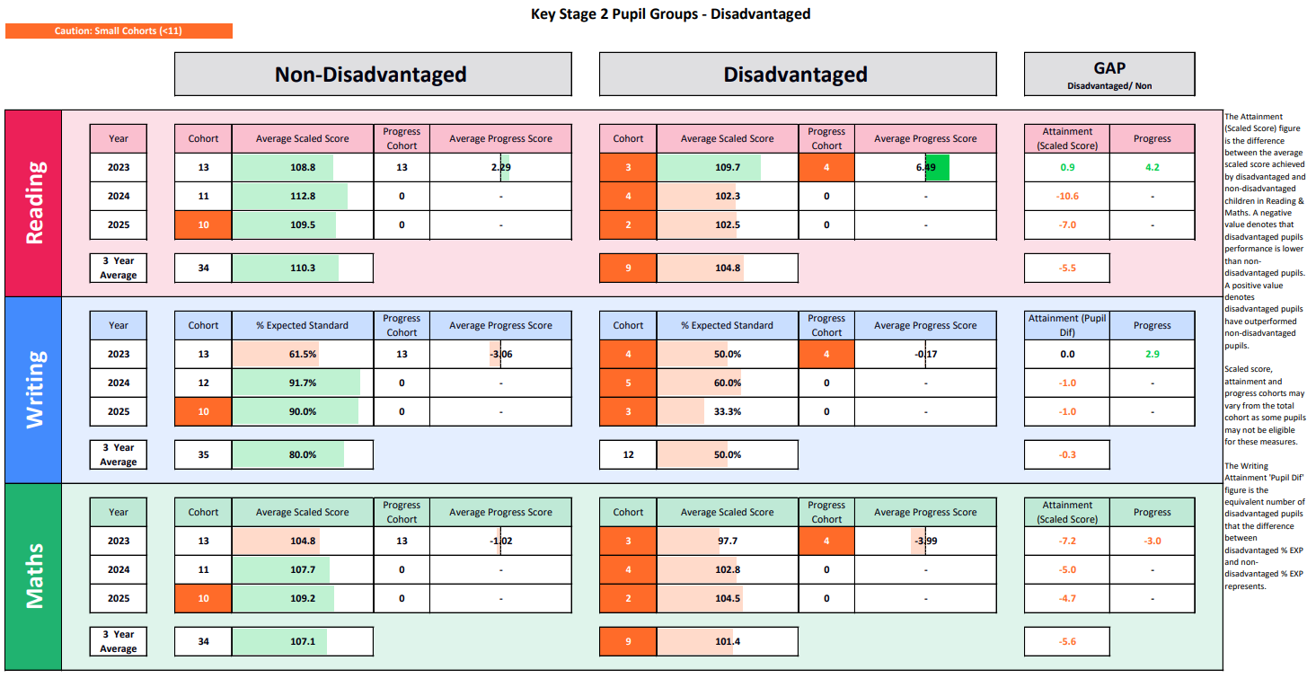

Externally provided programmes
Please include the names of any non-DfE programmes that you used your pupil premium to fund in the previous academic year.
Programme | Provider
Jigsaw PSHCE Ltd | Jigsaw PSHCE Ltd
Purple Mash 2 | Purple Mash 2
Accelerated Reader Renaissance | Accelerated Reader Renaissance

Service pupil premium funding (optional)
For schools that receive this funding, you may wish to provide the following information: How our service pupil premium allocation was spent last academic year
The impact of that spending on service pupil premium eligible pupils

Further information (optional)
Use this space to provide any further information about your pupil premium strategy. For example, about your strategy planning, implementation and evaluation, or other activity that you are delivering to support disadvantaged pupils that is not dependent on pupil premium funding.

