Perfect Pets

Pedrevan Class – Spring 1 2019
Personal, Social and Emotional Development
Children will be…
- Continuing to embed our Golden Rules throughout their school day.
- Developing their confidence to talk to other children when playing and communicating freely about own home and community.
- Learning to care for living things, including their new class pet!

Communication and Language
Children will be…
- Listening to stories about animals (e.g ‘Dear Zoo’) and discussing the events and characters in the stories.
- Asking and answering questions about different pets by asking experts and pet’s owners, looking in books and researching online.

Understanding the World/RE
Children will be…

- Learning the Christian creation story and interpreting it through music, movement and art.
- Learning and re-telling the bible story ‘Noah’s Ark’s and exploring the significance of the events.
- Making observations of real animals and finding out facts about them.
Phyiscal Development
Children will be…
- Climbing and exploring in the park.
- Learning invasion style games in PE with Miss Danks and Mr Webb.
- Enjoying themed yoga sessions
- Using different classroom equipment to perform different tasks (cutting with scissors etc) with greater precision.
- Changing independently for PE.

Mathematics
Children will be…
- Counting, reading, writing and ordering numbers to 20.
- Adding 2 small numbers by counting on from the biggest number.
- Subtracting small numbers by taking away and counting ‘how many are left’.
- Recording using the + and – sign.
- Carrying out a pet survey. Presenting the data in a simple graph and interpreting the results.

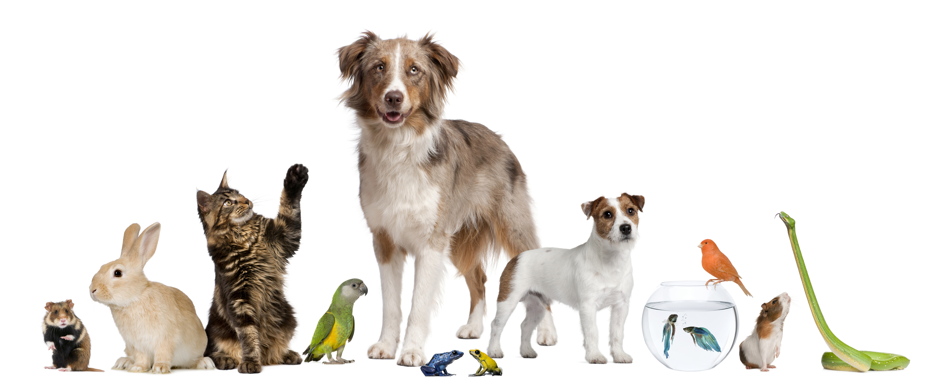

Expressive Arts and Design
Children will be…
- Painting animals.
- Designing and making clay animals.
- Designing and making a junk model aquarium.
- Singing songs about animals.
- Listening to Carnival of the Animals and then creating own animal music using the instruments, thinking about dynamics (fast/slow), volume (loud/quiet) and sound effects.
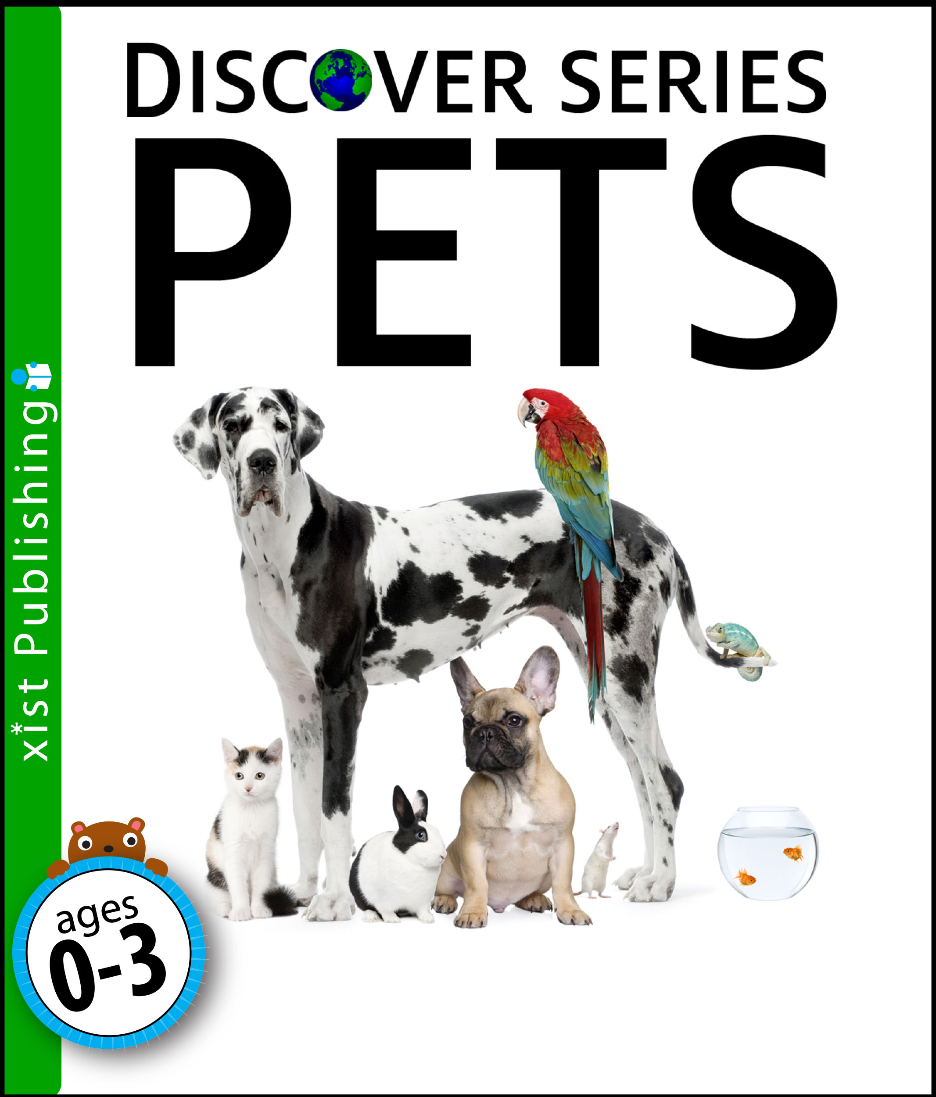
Literacy
Children will be writing…
- Sentences, using phonics and red words.
- Regular independent dairy entries
- Holiday news
- Lists of what pets need.
- A simple set of instructions about animal care.
- Labels and captions for an animal.
- Facts about a specific animal.

