

Ladock C of E School H & S Responsibilities and Arrangements Document

November 2021



**Celtic Cross Education**

**Health and Safety Policy and Index**

Table of Contents

1. Health, Safety & Welfare functions and responsibilities 4

2. Arrangements for the supervision of students 5

3. First Aid needs/procedures 6

4. Accident Reporting 8

5. Violent Incident Reporting 9

6. Evacuation and Registration Procedures 10

7. List of Fire Wardens 10

8. List of Team Teach trained staff 10

9. List of Working at Height trained staff 11

**School Statement of Intent**

This document should be read alongside the Trust’s Health and Safety policy and gives specific details on the way that the school manages Health and Safety.

Signed



Head of School Date: Date: 30.11.21

cid:257bec58-bb22-40a8-b34b-20529fa01e5b

Chair of the SMC Date: 30.11.21

# Health, Safety & Welfare functions and responsibilities

|  |  |  |
| --- | --- | --- |
| Function | Responsibility | Delegated to |
| First Aid Co-ordinator | Chris Stoyles | Elaine Milling |
| First Aid Appointed Person | Elaine Milling | N/A |
| Responsible person for pupils with medical needs | Chris Stoyles | Elaine Milling |
| Accident reporting officers | Chris Stoyles  Gary Standing | Jane Batchelor  Elaine Milling |
| Risk Assessment manager | Chris Stoyles | N/A |
| COSHH coordinator | Gary Standing | Jane Batchelor |
| DSE Assessor | Rebecca Drew | N/A |
| PPE coordinator | Chris Stoyles  Jason Gordon  Gary Standing | Jane Batchelor |
| School Security Company | PJI Security Ltd | N/A |

# Arrangements for the supervision of students

**Opening Times**

The School will be open from:

8:00am – Breakfast Club

8:40am – All other pupils

And will close to students at:

3:10pm – Normal school day ends

5:30pm – After school club finishes

Supervision arrangements

Supervision ratios and locations of supervisors between school/academy opening and lesson start time

* If children are on-site between 8.00 and 8:40, they are supervised at Breakfast Club where a minimum ratio of 1 adult to 10 children is in place.
* Any children arriving before 8:35 should be supervised by their parent/carer until 8:40 when the school doors open.

Supervision ratios and locations of supervisors at break and lunchtimes

* At breaktimes and lunchtimes there is a ratio of:
  + KS2 / ‘Top’ playground – 2:60
  + KS1 playground – 2:53

Areas to be used by students outside lesson times

* + KS2 playground
  + KS1 playground
  + ‘Top’ playground
  + Pitch (when suitably dry)

Supervision ratios and locations of supervisors between end of lessons and school closing time.

* Children should be collected promptly by their parent / carer and 3:10pm. Children are ‘handed over’ to the parent/carer from the classroom door onto the playground. Children may only leave without a parent / carer if we have written confirmation from the parent /carer that the child has permission to walk home alone (Y5/6 only).
* If children are on-site between after 3:10 and if not in an extra-curricular club, they should be supervised at After School Club where a minimum ratio of 2 adult to 20 children is in place.
* If a child is not collected by a parent/carer and does not have permission to walk home, they will remain supervised by the class teacher and the following procedures take place:
  + The parent/carer will be phoned after 15 minutes.
  + If school staff are unable to contact the parent/carer, emergency contacts for the child will be telephoned. The child will remain under the supervision of a member of staff – this may be in the after school club provision.
  + Contact numbers will continue to be retried.
  + If it has not been possible to contact the child’s parents/carers or an emergency contacts, the Social Services Access Team may be contacted in consultation with the HOS. This will be done at 4.15pm or 30 mins after the after school clubs finish.

# 3. First Aid needs/procedures

An assessment of first aid needs has been carried out and has identified that the following numbers of trained staff is required:-

First Aid at Work Qualified [ 1 ]

Emergency First Aid Qualified [ 2 ]

Paediatric First Aid Qualified [ 2 ]

Appointed Person [ 1 ]

Notifying parents

In addition to the procedures above, the school will notify parents/guardians of any other significant injury by way of:-

* a telephone call

Records of notification by telephone to parent/guardians will be logged by the office on assesnet. Original copies of written notification are sent home with the pupil. These will be scanned into a first aid sharepoint folder and stored on the school’s server. They are reviewed by the first aider and Head and the relevant ones are uploaded to Assessnet for CCE staff and CC staff to view.

**Medicine in School**

The School does not keep or dispense any other medication other than salbutamol for use with the emergency asthma kit (see below) and emergency epi-pen.

Self-Management of Medication

This School does not allow students to carry or manage their own medication.

Emergency Asthma Kits

This School’s procedures for managing the use of the emergency asthma kit is based on Department of Health guidance:-

<https://www.gov.uk/government/uploads/system/uploads/attachment_data/file/350640/guidance_on_use_of_emergency_inhalers_in_schools_September_2014__3_.pdf>

Staff authorised to dispense this medication have read the above guidance and have been given instruction in the recognition of the symptoms of an asthma attack and the appropriate procedures to follow.

The emergency inhaler contains Salbutamol and will only be available to students who have been

* diagnosed with asthma and prescribed an inhaler OR
* prescribed an inhaler as reliever medication.

In addition parental consent must be obtained for use of the emergency inhaler.

The School keeps a register of students who have been diagnosed with asthma or prescribed a reliever inhaler.

The emergency asthma kit will be stored and managed in the same way as any other prescription medication following the procedures above.

**Storage of Medicine**

Medicines will be securely stored in staff room fridge or disabled toilet lockable cupboard.

Any medicine given out or administered must be recorded through the medical folder through the Ladock School Network SharePoint page. Parent must complete the ‘Request to Administer Prescribed Medications’ electronic form before any medicine is administered.

**Facilities for Medical Procedures**

The secretary’s office/disabled toilet/school corridor is used for medications and medical treatments are also administered in these locations.

**List of first aiders**

|  |  |  |
| --- | --- | --- |
| Name of employee | Training course completed | Expiry date |
| Carly Denning | Paediatric First Aid | 15.01.22 |
| Tracy Eldridge | Paediatric First Aid | 07.02.22 |
| Elaine Milling | Paediatric First Aid  First Aid at Work L3 | 12.09.21  23.11.23 |
| Bethany Harris | Emergency First Aid | 13.03.23 |

# 4. Accident reporting

The following flowchart will be used within schools to determine how accidents/incidents need to be recorded

Accident slip and first aid is sufficient

Phone call to home/main contact to report injury to ensure the child is under observation for 72 hours following accident.

School to monitor closely for any change.

Bone break/head, neck or back injury where further treatment or hospitalisation required?

Assessed and treated by first aider injury where child is deemed well enough to stay in school. Class teacher to be informed.

Accident—Fill out GDPR accident form and take to office. Office to scan a copy into first aid folder tab.   
Hard copy to go home with pupil.

Deemed an Injury has occured

Parent/ambulance collection arranged.

Details of times etc. recorded and incident recorded and reported on AssessNet

https://www.assessweb.co.uk

Follow up report and investigation completed by Head/SLT

Monthly audit of accident slips to highlight patterns and take action accordingly.

All cuts and grazes will need to be assessed by the first aider / Head of school as to whether they need reporting online or if first aid treatment/accident form is adequate.

All head injuries with the exception of head bumps need reporting online. Head to monitor head bumps for patterns.

**5. Violent incident reporting**

The following flowchart will be used within schools to determine how violent incidents need to be recorded.

All Violent incidents to be logged on Assessnet system

Head to decide if the incident needs logging on other software—ie My Concern etc.

Violent incident has occurred

Please fill out as much information as possible on the violent incident form

Monthly audit of violent incidents to highlight patterns and take action accordingly.

Form handed to office and scanned into computer folder for storage. Head to be notified of incident.

# 6. Evacuation and Registration Procedures

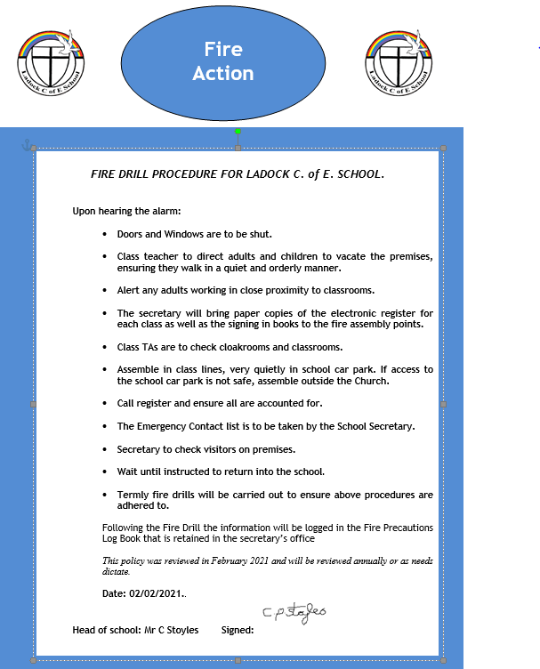

# 7. List of Fire Wardens

|  |  |  |  |
| --- | --- | --- | --- |
| Name of employee | Training course completed | Course date | Expiry date |
| Jane Batchelor | Fire Warden Duties | May 2021 | May 2024 |

# 

# 8. List of Team Teach trained staff

|  |  |  |  |
| --- | --- | --- | --- |
| Name of employee | Training course completed | Course date | Expiry date |
| Elaine Milling | Team Teach – positive handling strategies | September 2020 | September 2022 |
| Chris Stoyles | Team Teach – positive handling strategies | February 2020 | February 2022 |

# 9. List of Working at Height trained staff

|  |  |  |
| --- | --- | --- |
| Name of employee | Training course completed | Course date |
| Chris Stoyles | Flick Training – working at height | Academic Year 2020 |
| Jane Batchelor | Flick Training – working at height | Academic Year 2020 |
| Carly Denning | Flick Training – working at height | Academic Year 2020 |
| Jessica Norgard | Flick Training – working at height | Academic Year 2020 |
| Bethany Harris | Flick Training – working at height | Academic Year 2020 |
| Janine Tringham | Flick Training – working at height | Academic Year 2020 |
| Caroline Burley | Flick Training – working at height | Academic Year 2020 |
| Elaine Milling | Flick Training – working at height | Academic Year 2020 |