
How much do we know about space?

St. Cuby Class - Spring 2017
Personal, Social and Emotional Development
Children will be…
- Playing co-operatively as astronauts in our exciting ‘space ship’ role play.
- Taking steps to resolve conflicts with other children (e.g. by finding a compromise).
- Describing themselves in positive terms and talk about abilities and interests during show and tell.

Communication and Language
Children will be…
- Using talk to clarify their thoughts, by questioning and explaining (e.g. asking ‘why’ things happen).
- Following 2-part instructions.
- Listening to other’s ideas and take account of what they say.

Phyiscal Development
Children will be…
- Learning new skills in PE with Mr Jarvis.
- Continuing to enjoy the pirate ship and builder’s yard in our outdoor area.
- Using tools and resources such as pencils, scissors, hammers, puzzles, beads, pegs etc to develop fine-motor skills.
- Practising self-dressing for PE and fastening own shoes and coats.
- Joining in with weekly yoga style exercises to improve gross motor skills.

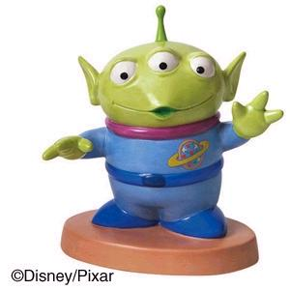
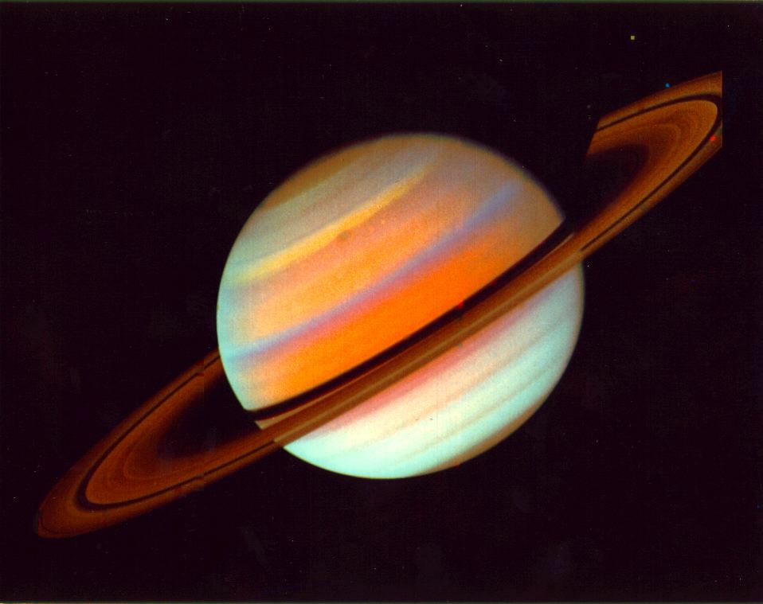
Literacy
Children will be writing…
- Simple sentences in phonics, using the sounds and ‘red’ words they know.
- The beginning, middle and end of the story “Whatever Next?”
- Letters to the aliens from the story “Here come the aliens”.
- Labels and captions for their planets and aliens.

RE
Children will be…
- Learning why the word God is so important to Christians.
- Finding out why Christians put a
cross in an Easter garden.

Understanding the World
Children will be…
- Completing programmes on the Ipads and using the internet to research facts.
- Learning the names of the planets, how day and night are created and identify sources of light and how light is reflected.

Mathematics
Children will be…
- Using the story “Aliens Love Underpants” as inspiration for their own patterns.
- Making rockets using 2D and 3D shapes.
- Addition of 2 small numbers.
- Finding 1 more/less than a number.

Expressive Arts and Design
Children will be…
- Making tin can rockets, papier mache planets and play dough aliens.
- Using instruments to create ‘space’ music.
- Cooking space-themed biscuits.

