Tony the Terrific Turtle!
You will need:
Scraps of fabric
Needle and thread
Stuffing – I used ripped up tissue paper
Felt pen
Scissors
An old bit of paper for the pattern - I used an old envelope

What to do:
First cut out the shell- you will need two pieces of the same shape. I used two different colours as I didn’t have enough of one colour! | 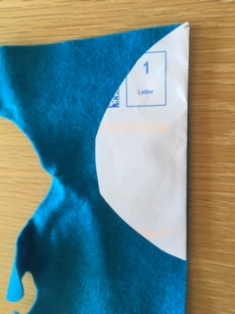
Next cut out the belly. I used a different colour again for this. | 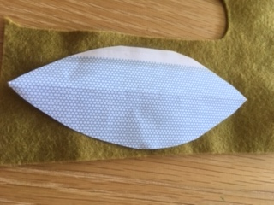
Now put the two shell pieces together – be careful to make sure they match! Thread your needle and put a knot in the end of the thread then sew around the curved bit of the two shell pieces. I left the needle and thread attached so that I could use it to sew the shell to the belly later on but you can fasten it off and cut it if you want to – see instructions below for fastening off. | 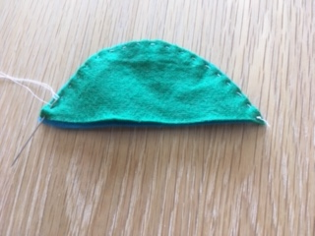
Now cut out two back flippers and two front legs. I didn’t use a pattern piece for this because they were quite small – but I have included the pieces on the pattern sheet if you want them. | 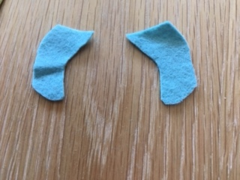
Now stick the legs and flippers onto the belly. You can sew them on if you don’t have any glue. | 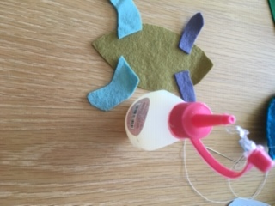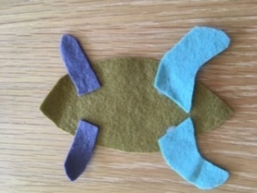
While the glue is drying, cut out two head pieces and sew them together around the curved bit. Don’t sew along the straight edge as you will need to put the stuffing in here! | 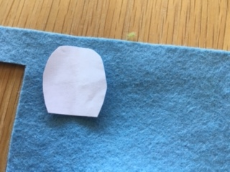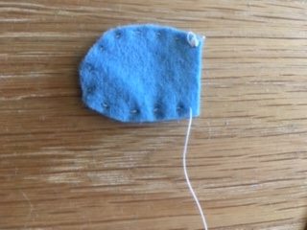
It’s time to stuff the head! You can use cotton wool, bits of material, rice or even ripped up paper. I used ripped up tissue paper. Open up the head along the straight edge and gently push in a little bit of stuffing – be careful not to over fill! | 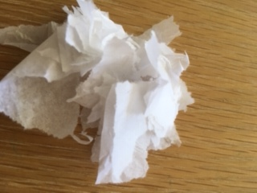
Now sew along the straight edge. Don’t cut off the thread, keep it attached. Put the head on the front of the belly and sew it in place. Fasten off securely. | 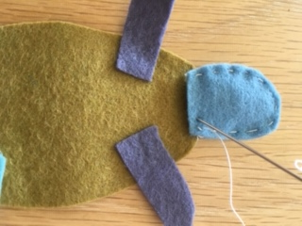
TOP TIP – how to fasten off.  Make a stitch but don’t pull it through completely. Leave a loop.  Put the needle through the loop.  Gently pull the thread so that the loop gets smaller and smaller and then forms a knot.  Now repeat the whole process again twice to make it really secure. | 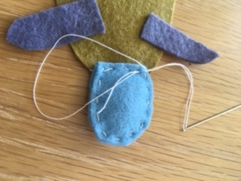  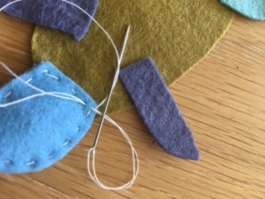  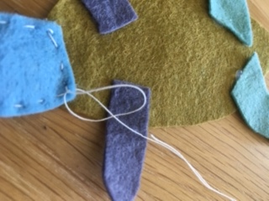
This next bit is probably the trickiest!  The shell now needs to be attached to the belly. I pinned the back of the shell to belly ensuring that the pointy bits lined up. | 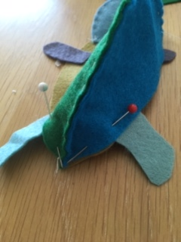
Sew the shell to the belly but when you get to the head, fold the shell to make a straighter edge.  Stop sewing when you have about 3cm left as you now need to stuff the body. | 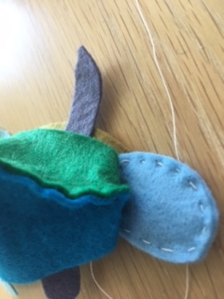
Gently push the stuffing into the body – don’t over fill! | 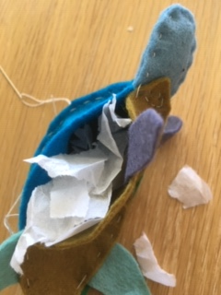
Sew up the rest of the body. I found that the belly was a little bit big so I made a tiny pleat or fold in order to make it fit. It is underneath the turtle so no-one can see it! | 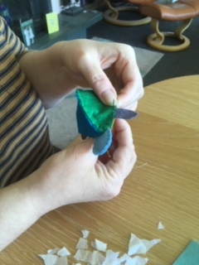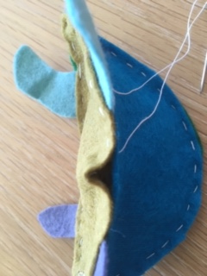
Finally, Tony Turtle needs some eyes! I drew these on with a felt pen ….. and there we go, a terrific turtle pal to keep you company!  Tony was very interested in my cup of tea! | 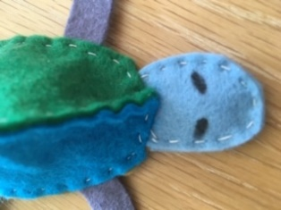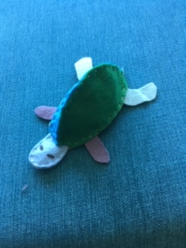  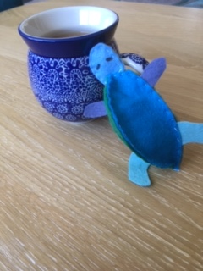

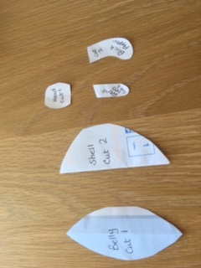
Pattern pieces
You can use the measurements to draw your own, or print off the photos and cut out the shapes. You don’t need to be too precise! The important measurement is to get the straight edge of the shell the same length as the belly.

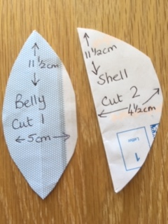
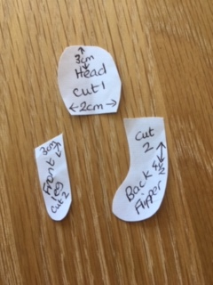
Cut 2

