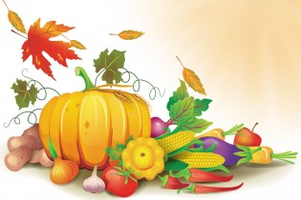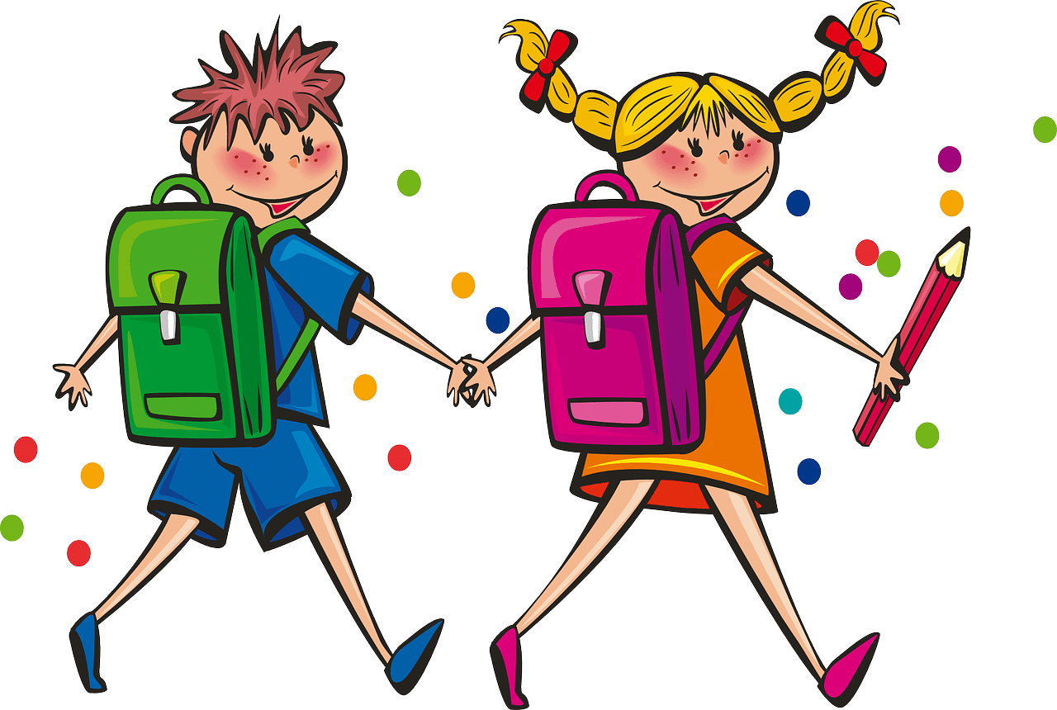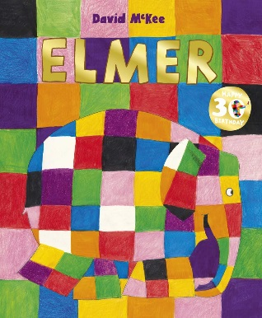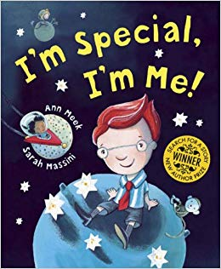

**Religious Education**

Children will be…

* Discussing our school values.
* Exploring and wondering about the natural world.
* Discussing the importance of Harvest.
* Understanding Christianity – Creation
* Looking after our world

**Mathematics**

Children will be…

* Counting up to 20; learning to move/ cross out the objects counted.
* Counting to 20; matching quantities to numerals.
* Measuring bigger than/smaller than.
* Beginning to add 2 sets of objects.
* Adding one more.
* Creating repeating patterns of 2 or more objects/colours.

**Physical Development**

Children will be…

|  |  |
| --- | --- |
| * Climbing and exploring the pirate ship. * Learning new multi-skills with Mr Webb in PE! * Enjoying weekly themed yoga sessions. | * Using different classroom equipment to perform different tasks (cutting with scissors etc). * Learning to hold a pencil correctly. * Changing independently for PE. |

**Expressive Art and Design**

Children will be…

* Learning songs about ourselves.
* Drawing around our hands to create a book
* Painting pictures from stories and talking about our work.
* Creating self-portraits in the style of a character
* Creating patterns using a variety of objects.

**Understanding the World**

Children will be…

* Researching the types of animals we would find throughout the different seasons of the year.
* Discuss what we know about animals.
* Looking at how people can be the same and different from each other.
* Understanding that people enjoy different things.

**Literacy**

Children will be…

* Writing about myself and my favourite things.
* How to structure a story and act them out in my play.
* Hot seating characters from a story and thinking about why characters do the things they do,
* Learning a story.
* Describing and talking about characters.
* Using speech bubbles to show when someone is talking.

**Personal, Social and Emotional Development**

Children will be…

* Deciding the’ Golden Rules’ for the classroom.
* Building relationships and learning to play cooperatively.
* Playing games together to practise sharing and turn-taking.
* Discuss ways in which we are the same/different from each other.

**Communication and Language**

Children will be…

* Listening carefully to stories.
* Sharing books with their Y6 buddies.
* Using the stories ‘I’m Special, I’m Me!’ and ‘Elmer’ as a stimulus for discussion.
* Taking it in turns to talk during conversation.
* Learning a story and being able to tell it myself or as a group.

**All About Me**

**St Cuby Class**

**Autumn 1**

**2019**