The Last Straw
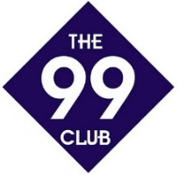
The 99 Club was founded in 2006 and in that time, only 6 children have ever completed ‘The Last Straw’
Could you be the 7th?

