in using Microsoft office, carrying 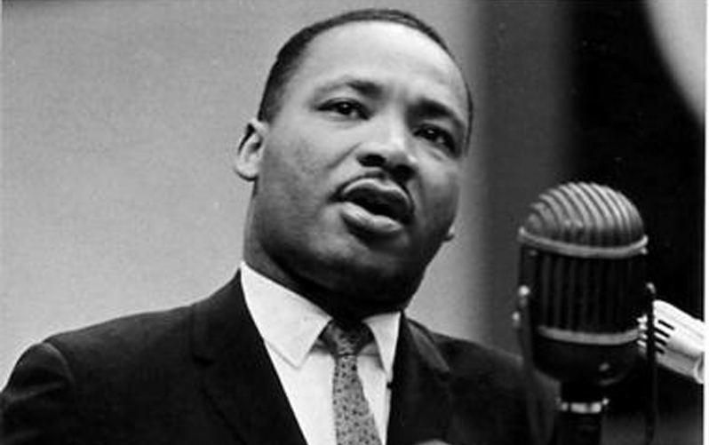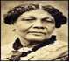
‘I have a dream…’
Ladoca Class
Summer 2018
DT
Ladoca class will be working and exploring with the use of clay to create African inspired masks.

RE
RE this term will be exploring non-Christian units. In Ladoca we will be learning about the Hindu faith and discovering the different customs and beliefs.

Science
This term Ladoca class will study changes of state-compare and group materials together, according to whether they are solids, liquids or gases. Later in the term we will also explore the water cycle- identify the part played by evaporation and condensation in the water cycle and associate the rate of evaporation with temperature. They will be developing skills to ask relevant questions related to their scientific observations.

History
For our topic this term, Ladoca class will be drawing on elements from Black History month-researching, using a range of sources about our knowledge of the past, the process of change, the diversity of societies and relationships between different groups and learning about inspirational people both historical and contemporary such as Martin Luther King, Walter Tull, Mary Seacole, Lewis Hamilton, Barrac Obama, Mo Farrah and Jessica Ennis.
INCLUDEPICTURE "https://encrypted-tbn0.gstatic.com/images?q=tbn:ANd9GcR4EzQrh3SBqQg_ynPGfUCdLnOUmkVDw14rO1MunulTk-uhMz96" \* MERGEFORMATINET
Geography
We will use maps to locate countries of the world, considering temperature, physical and human features. We will learn how to use keys and symbols on maps as well as how to use a compass.
Maths
Ladoca class will begin this term with place value and then develop our number work to the four operations using whole numbers. In everything we do, we will be focussing on developing fluency, reasoning and problem-solving skills. Please continue to support your child by working on the weekly tables and with homework.

PHSE
Children will be considering the statement ‘I have a dream’ and exploring their own and other people’s hopes, dreams and aspirations.
Music
This term we will be exploring both contemporary music from artists such as Joan Armatrading, Jimi Hendrix …as well as taking the opportunity to have ago at listening to and creating some of our own African inspired music as well as creating a piece which includes the use of costume.

Computing

The children will be developing skills and carrying out research using Microsoft word, as well using search engines effectively, to carry out a range of work this term.

Art
Linked to our theme of inspirational black people and multiculturalism, children will be exploring features of African based art such as Gakonga (Kenya) as well working with clay.
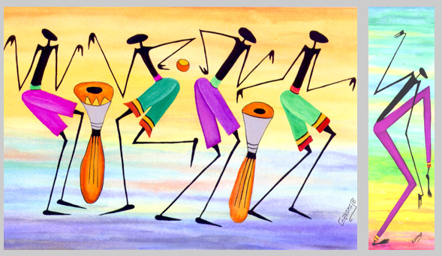

English
Children will write for a range of purposes including poetry, letter writing, diary and narrative. We begin this term exploring features of non-fiction text, learning and performing poetry from contemporary children’s poet Diane Z. Shore( This is the Dream) and Maya Angelou (Poetry for Young People) and recount. We will then look at non-fiction text as well as fiction stories from other cultures. We will continue to work on spelling, punctuation and grammar. Regular reading both at school and home will be a central focus to learning and enjoyment of different genres.

Games/PE/Gym
Mr Jarvis will be teaching flexibility and control in gymnastics. He will also be teaching tennis this term.
Mrs Argent plans to carry out some outdoor learning in preparation for year 3 camp but envisages extending this to all of Ladoca class in due time.

